**Date of the Progress Review**

|  |
| --- |
| 24/11/2023 |

**Summary Dashboard**

|  |  |  |  |
| --- | --- | --- | --- |
| **Schedule On** | | **Budget**   **On** | |
| **Planned work** | **Planned work is done** | **Actual Cost $** | **$** **5,125.00** |
| **Actual work** | **Design/prototype-100%**  **Functionality-100%** | **Remaining Cost $** | **$800** |
| **% work complete** | **93%** | **Baseline Cost $** | **$0.00** |
| **Remaining work** | **7% - close out** | **Variance $** | **$5,925.00** |

**Project Progress to date**

The project is up-to speed and has occurred no difficulties, it has been running on budget the entire time with work being finished at or just ahead of schedule. The Team has been collaborating well and has completed all website tasks, we had managed to show the website a few hours ahead of schedule with the client and got their approval.

**Product Status**

|  |  |  |  |  |  |
| --- | --- | --- | --- | --- | --- |
| **Functions** | **Proportion of function completed %** | Compliance with IT works coding standards (%) | Compliance with website security requirements (%) | Compliance with website Accessibility requirements (%) | Comments (optional) |
| Server-side: |  |  |  |  |  |
| * Connect to Database | 100% | 100% | 100% | 100% |  |
| * Register | 100% | 100% | 100% | 100% |  |
| * Login | 100% | 100% | 100% | 100% |  |
| * Display products | 100% | 100% | 100% | 100% |  |
| * Search products | 50% | 50% | 0% | 50% | Structure is there but needs to be implemented |
| * Add to cart | 100% | 100% | 100% | 100% |  |
| * View Cart | 20% | 100% | 100% | 100% |  |
| * Remove from cart | 100% | 100% | 100% | 100% | Button is there and has been implemented |
| * Checkout | 100% | 100% | 100% | 100% | Checkout and payment processing has been complete |
| Client Side: |  |  |  |  | There are no client side aspects of the website as everything was done effectively in PHP |
| Client report: |  |  |  |  |  |
| * Documentation | 100% | 100% | 100% | 100% | This was done on schedule but before this report was due hence its inclusion |
| * Demo site | 100% | 100% | 100% | 100% | This was done on schedule but before this report was due hence its inclusion |

**Project Status**

Record relevant information as at the reporting date identifying both the schedule and budget baseline data measured against actual performance and budget to-date. Justify any variations between planned and actual results and the corrective actions (if required).

Current completion status is at 93% with all of the coding complete. The cost is also on budget, the Client demonstration and documentation was done a few hours ahead of schedule, although this did not reduce costs.

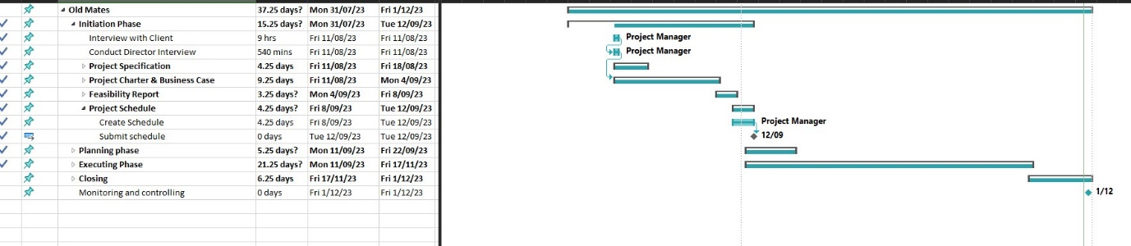

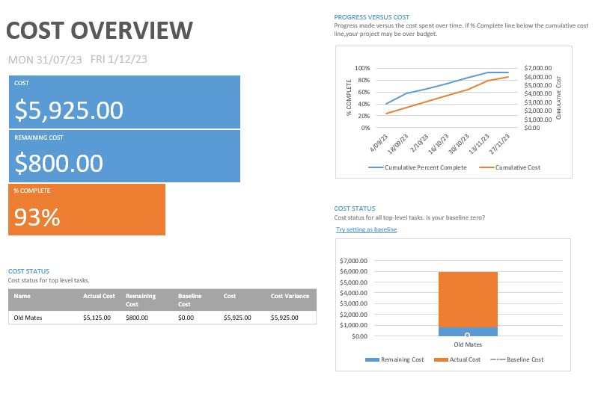

**Risks and Issues**

Update the risk assessment to reflect current risk situation

|  |  |  |  |  |
| --- | --- | --- | --- | --- |
|  | Risk | Status: Active  Dormant  Retired | Risk Monitoring Method | Risk Mitigation or Corrective Action taken during the reporting period [Comment required for active risks] |
| R1 | Project runs behind schedule | Retired | Monitored through scheduling tool | Monitor Project Schedule and follow up with team members on any issues. All website tasks are done, project is in closeout stage |
| R2 | Project runs over budget | Retired | Monitored through scheduling tool | Monitor Project Schedule and ensure tasks are done on time. All website tasks are done, project is in closeout stage |
| R3 | Client's expectations are set too high | Dormant | Monitored through regular client meetings |  |
| R4 | Sponsors / client disengage | Dormant | Monitored through regular client meetings |  |
| R5 | Unexpected Scope changes | Retired | Monitored through Product Status & Project Change request | Monitor any change requests from client, ensure all expectations are understood, fill out change request form |
| R6 | Team member falls ill / unavailable | Retired | Monitored through team meetings and team communications | All website tasks are done, project is in closeout stage |
| R7 | Team members leave | Retired | Monitored through team meetings and team communications | All website tasks are done, project is in closeout stage |
| R8 | Team interaction and performance is below expectations | Retired | Monitored through team meetings and Product status and scheduling tool | All website tasks are done, project is in closeout stage |

**Completion**

The current progress has been going as expected, the website is now finished by there are no expected risks or delays, any proposed changes can be added if more time and budget is allocated. The Client demonstration was completed a head of schedule. closeout documentation will now commence

**Updates**